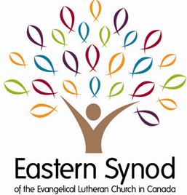
  - Visit Details for Bishop and Assistants
  - Please complete the following form and return to the Synod Office as soon as possible. Thank you!
“For where two or three are gathered together in my name,
  - There am I in the midst of them.” Matthew 18:20

  - Information
Date
Congregation
Location of Service(s)
Celebrant
Preacher
Children’s Message
Parking Options

  - Service Details
Service Time(s)
Service Type
Book to be Used and Setting
Liturgical Colour
Lections: Proper:
OT
Psalm
NT
Gospel
Service Music/Special Music

  - Other Information

