YEMANJA GODDESS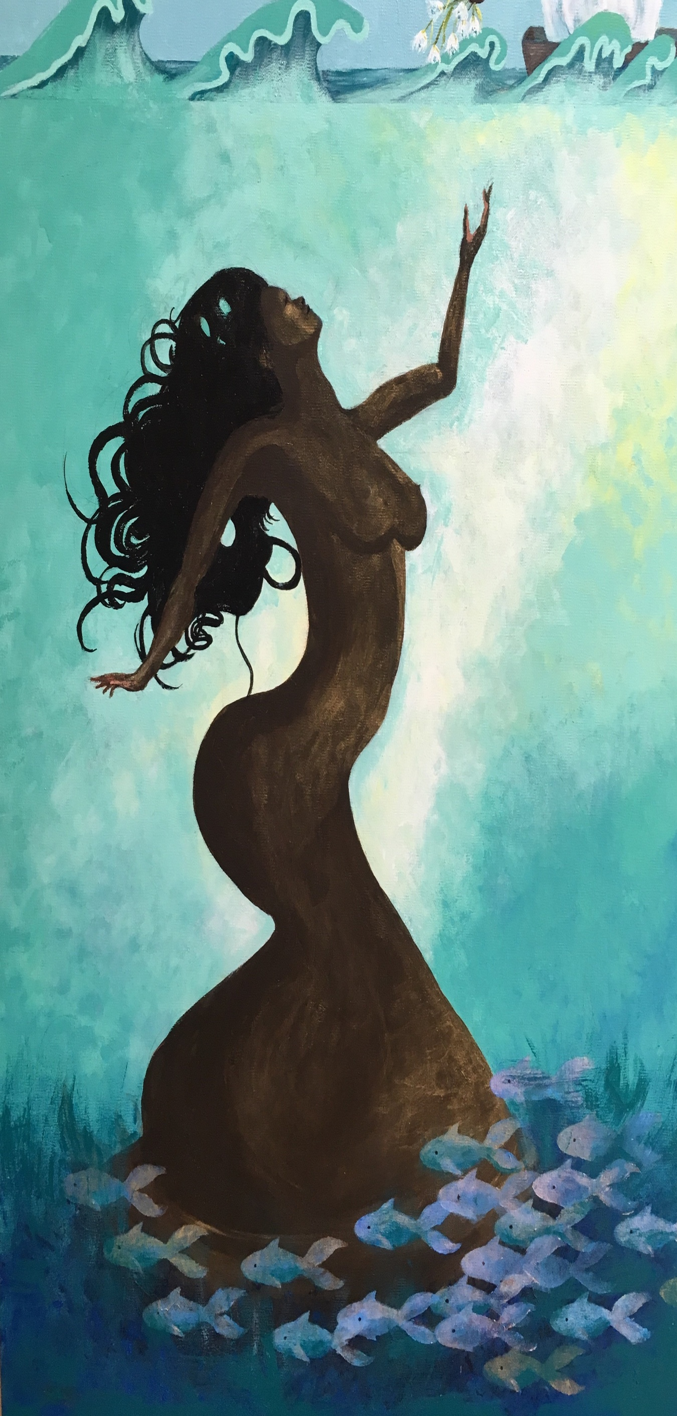
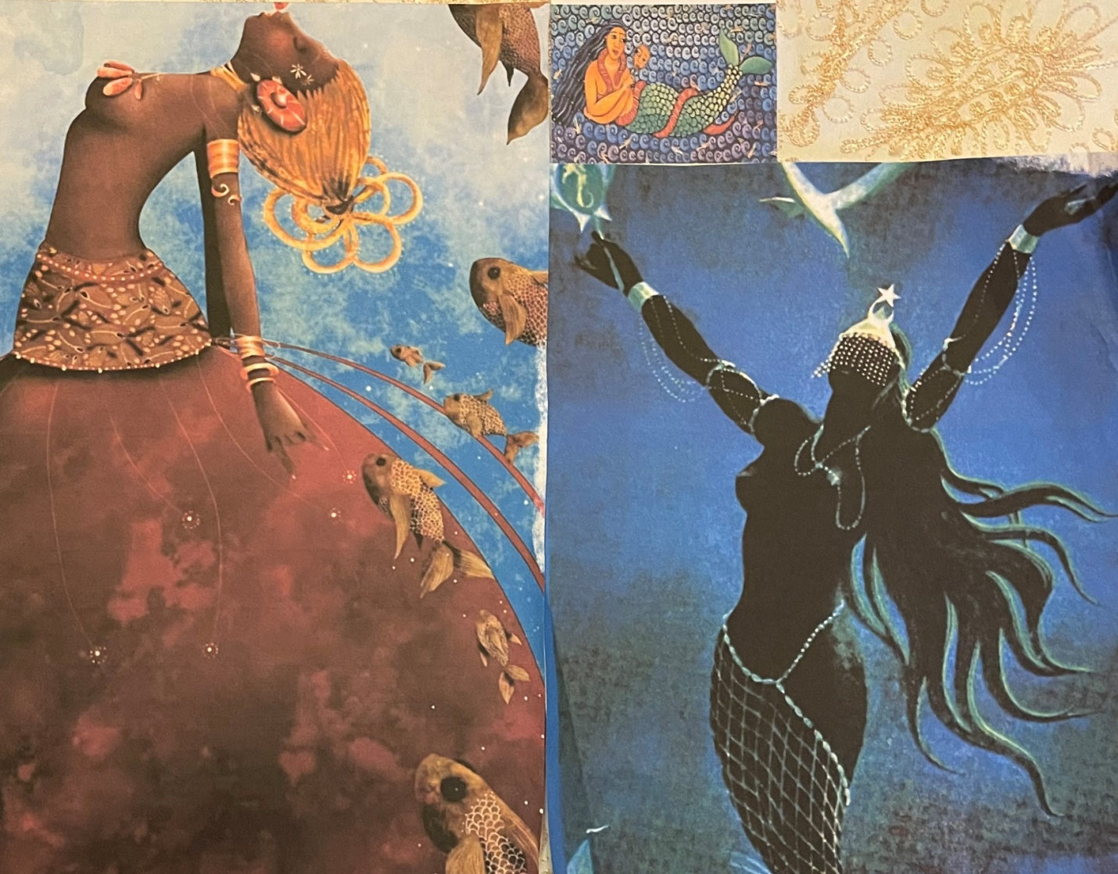
Yemanja (Yemaya, Yemoja, Iemonja, Iamanje) is a beloved goddess of the sea. She is such an important goddess that came from Western Africa with slaves and is celebrated in many public and private ceremonies throughout the Caribbean, and in North and South America. She was brought to the New World by the African diaspora.
She controls the surface of the ocean where life is concentrated. She determines whether or not fish will be caught and whether fishermen will return to shore safely. All life is held to have begun in the sea.In Brazilian Candomble she protects boats traveling on the sea. She is equated elsewhere in the Americas with the Virgin Mary and the Great Mother. In Haiti Voodoo she is worshiped as a moon goddess. Her sign is the crescent moon. In parts of Brazil she is honored at the summer solstice. Elsewhere her festival is held on February 2nd with large crowds drumming, dancing,, chanting and offering blue and white floral bouquets into the ocean to honor her. If she accepts them and they are swallowed by the surf, the wishes of the worshiper will be granted. Videos of these celebrations make you want to join in.
View YouTube video: “Brazil Worshippers celebrate sea goddess Yemanji”https://www.google.com/search?q=yemanja+celebration+brazil&ie=UTF-8&oe=UTF-8&hl=en-us&client=safari#fpstate=ive&vld=cid:c0b371d8,vid:GL0vv9EwWy8,st:0

