Trinity Shares: You're Invited - Trinity Village Grand Parade & Community Engagement Day 🎉
September 4th, 2025

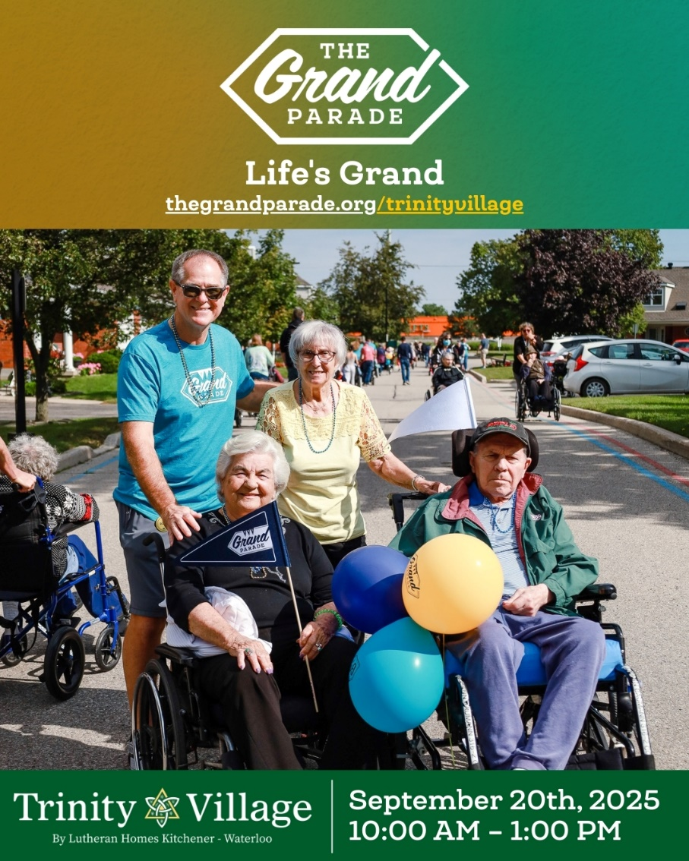

On behalf of Debby Riepert, I am following up on our invitation to you for two special events that celebrate community, compassion, and connection: our upcoming 8th Annual Grand Parade & Community Engagement Day that will be held together this year on Saturday, September 20th, 2025 Walk, roll, celebrate, and make a difference at our biggest annual fundraiser! There will also be live entertainment, BBQ, ice cream truck, vintage car show, lawn games, and more happening on our Trinity Village grounds. All proceeds support expanding services for our residents and community — pets welcome! This year’s Fundraising Goal for the Annual Grand Parade is 25K!!!

How You Can Get Involved:
- DONATE – Support Team Trinity Village. (Click HERE)
*Donation cheques must be payable to The Grand Parade.
- JOIN THE TRINITY VILLAGE TEAM – Walk with us! (Click HERE) Click on the “Register Join Us & Fundraise” icon, acknowledge, and sign the waiver. Click on Join a Team; Enter Trinity Village and click Search. Click on Trinity Village and Next. Enter your contact information and create an account. Enter a personal amount/goal. Select Main Event and click Yes! Register Me Now.
- VOLUNTEER – Help with setup, registration, BBQ, traffic, walking with residents, and more.
- CHEER – Come out and encourage participants!

Event Schedule:

- 9:30 a.m. - 10:30 am: Check-In/Registration
- 10:30 am: Opening Remarks - Send-Off
- 11:30 am: BBQ Lunch
- 11:30 am - 1:00 pm: Live Music
- 12:00 pm - 1:30 pm: Megacone Ice Cream Truck

For questions about the Grand Parade or how to get involved as a sponsor, volunteer, or supporter, please contact Maria Menounos, Program Manager, by email at mmenounos@trinityvillage.com or call 519-893-6320 ext. 245 or contact Camila Llano, Marketing Supervisor, at marketing@trinityvillage.com or call 519-893-6320 ext 303.

We appreciate your contribution to Trinity Village and helping us reach our goal!

Respectfully Yours,

Debby Riepert,
Chief Executive Officer
Trinity Village/LHKW

