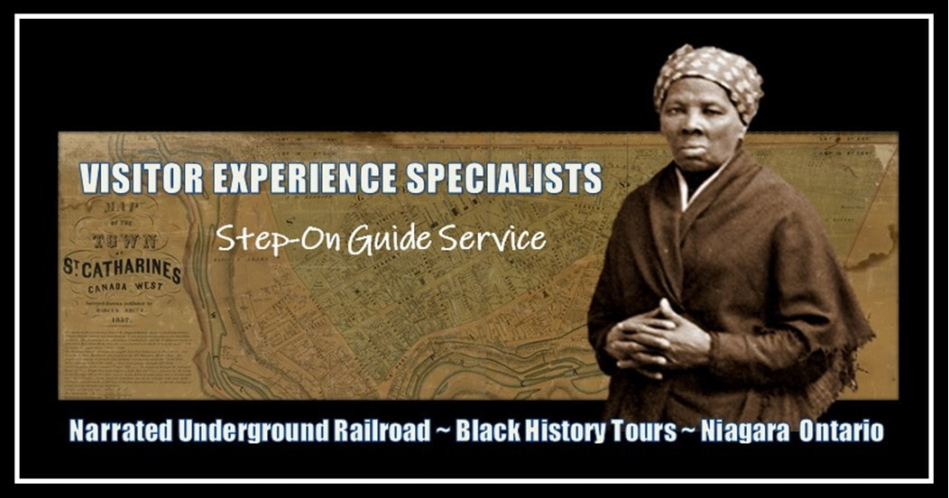

TRACING HARRIET TUBMAN AND THE FREEDOM SEEKERS
​FROM THE UNITED STATES TO CANADA​​​​​​​

OUR EXCLUSIVE HARRIET TUBMAN TOUR COVERS THE YEARS ​THE LEGENDARY UNDERGROUND RAILROAD CONDUCTOR SPENT IN ​​  ST. CATHARINES. | ​  ​Highlighting the British Canadian town that served as Harriet Tubman's home and base of operations during the 1850s, visitor groups will enter the Salem Chapel, BME Church, National Historic Site where the fearless woman called "Moses" praised the Lord. Visitors will explore the city where Harriet Tubman guided her elderly parents and three brothers, hear about other famous abolitionists and learn what life was like for the freedom seekers in Canada. ​

WE PROVIDE FACT BASED HISTORY TOURS
THAT ARE PRESENTED BY ​AFRICAN CANADIAN STEP-ON TOUR GUIDES

Visitor groups will enjoy a fun, yet educational Black history tour presented by a ​descendant of African American freedom seekers. ​Our knowledgeable guide(s) will step on board your bus and escort your group to Niagara's featured Black history attractions and beyond. | ​OUR TOURS ARE UNIQUE AND WERE CREATED WITH THE SUPPORT AND INPUT OF LOCAL EXPERTS THAT INCLUDE:  ​SCHOLARS, HISTORY-HERITAGE ENTHUSIASTS, INDEPENDENT RESEARCHERS AND TOURISM CONSULTANTS.

READ OUR TOUR REQUIREMENTS
https://tubmantourscanada.com/index.html

