OYA GODDESS OF CHANGE
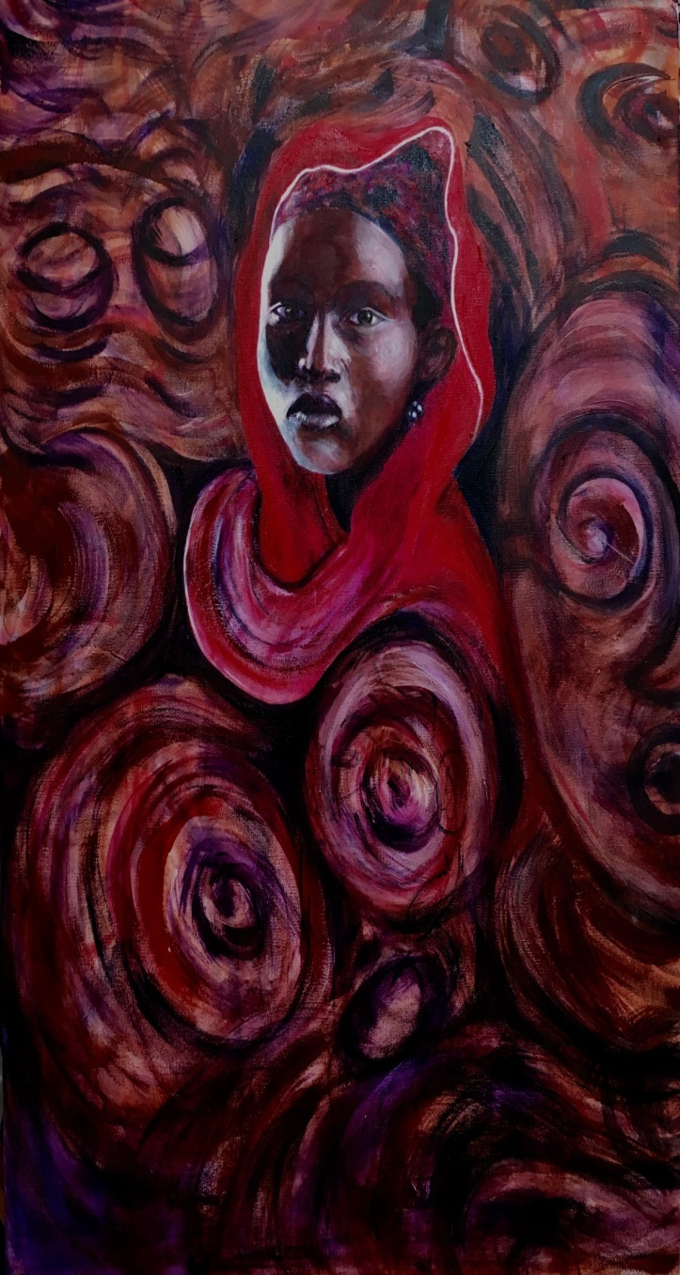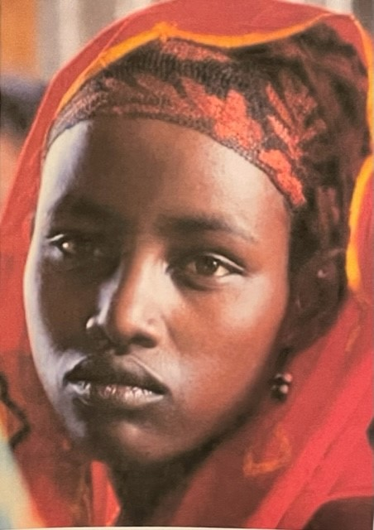
OYA (Oh-yah) is a Yoruban GODDESS OF CHANGE. She is an ORISHA (spirit) in traditional religious beliefs among the Yoruba in Benin and Nigeria.She can bring storms, lightning, floods, hurricanes and tornadoes when her wrath is provoked by injustice. A major Nigerian River is named after her, ODO - OYA.She controls the air that humans breath thus she is a guardian at cemeteries and eases passage into the next world. She is one of the children of the Mother of the Sea, YEMOJA.
This portrait is that of a young Yoruban woman. In the background you see swirls of energy similar to the patterns found in the 300 basalt steles that are found in the Gross River area. These monoliths came under scrutiny recently. Their age and origin remain a mystery.
I loved her face. She seems so young and yet so wise.

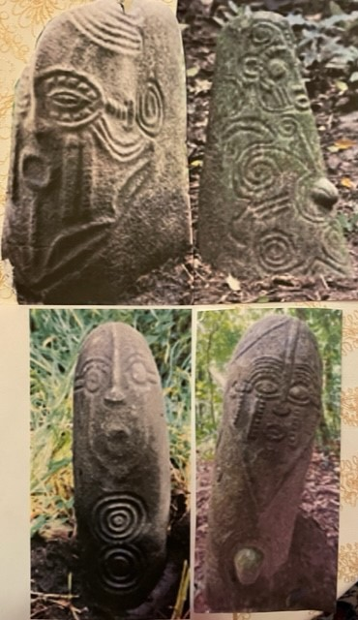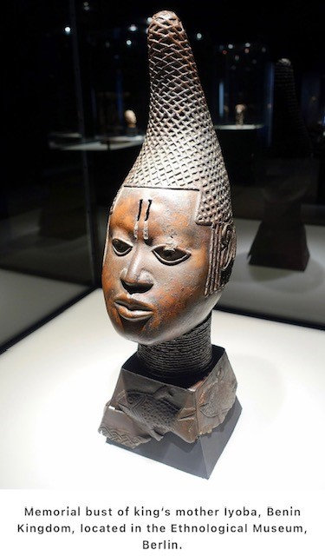
The world famous Benin Bronzes were made by Yoruban artisans. Thousands of them are in museums around the world. Many were stolen in 1897 from the British Museum. Negotiations are underway for their return. In the 19th century scholars thought some lost Greeks must have made them because they couldn't possibly be made by the natives. They were.
Less well known are these 4 ft. tall basalt steles. Very unusual in African art, they represent spirits. Conferences have recently been organized to examine their origin.
9 Centuries of African Art and Thought by John Drewal and Rowland Aboidun is one of the books that documents the extraordinary artistic gifts of the Yoruba.

