NANA BURUKU
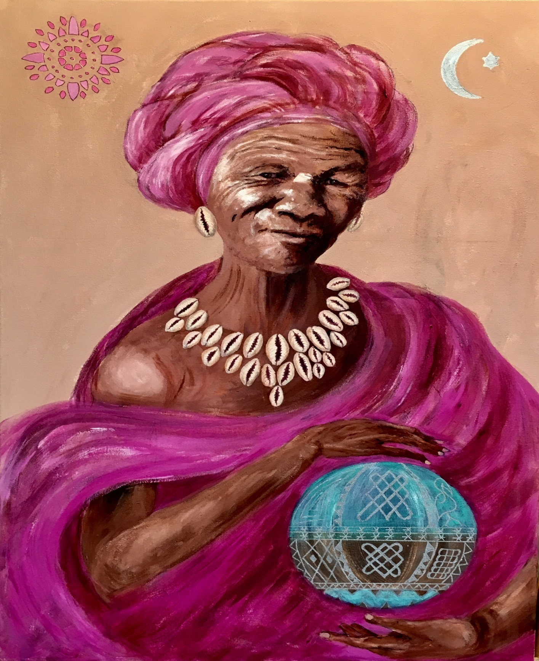

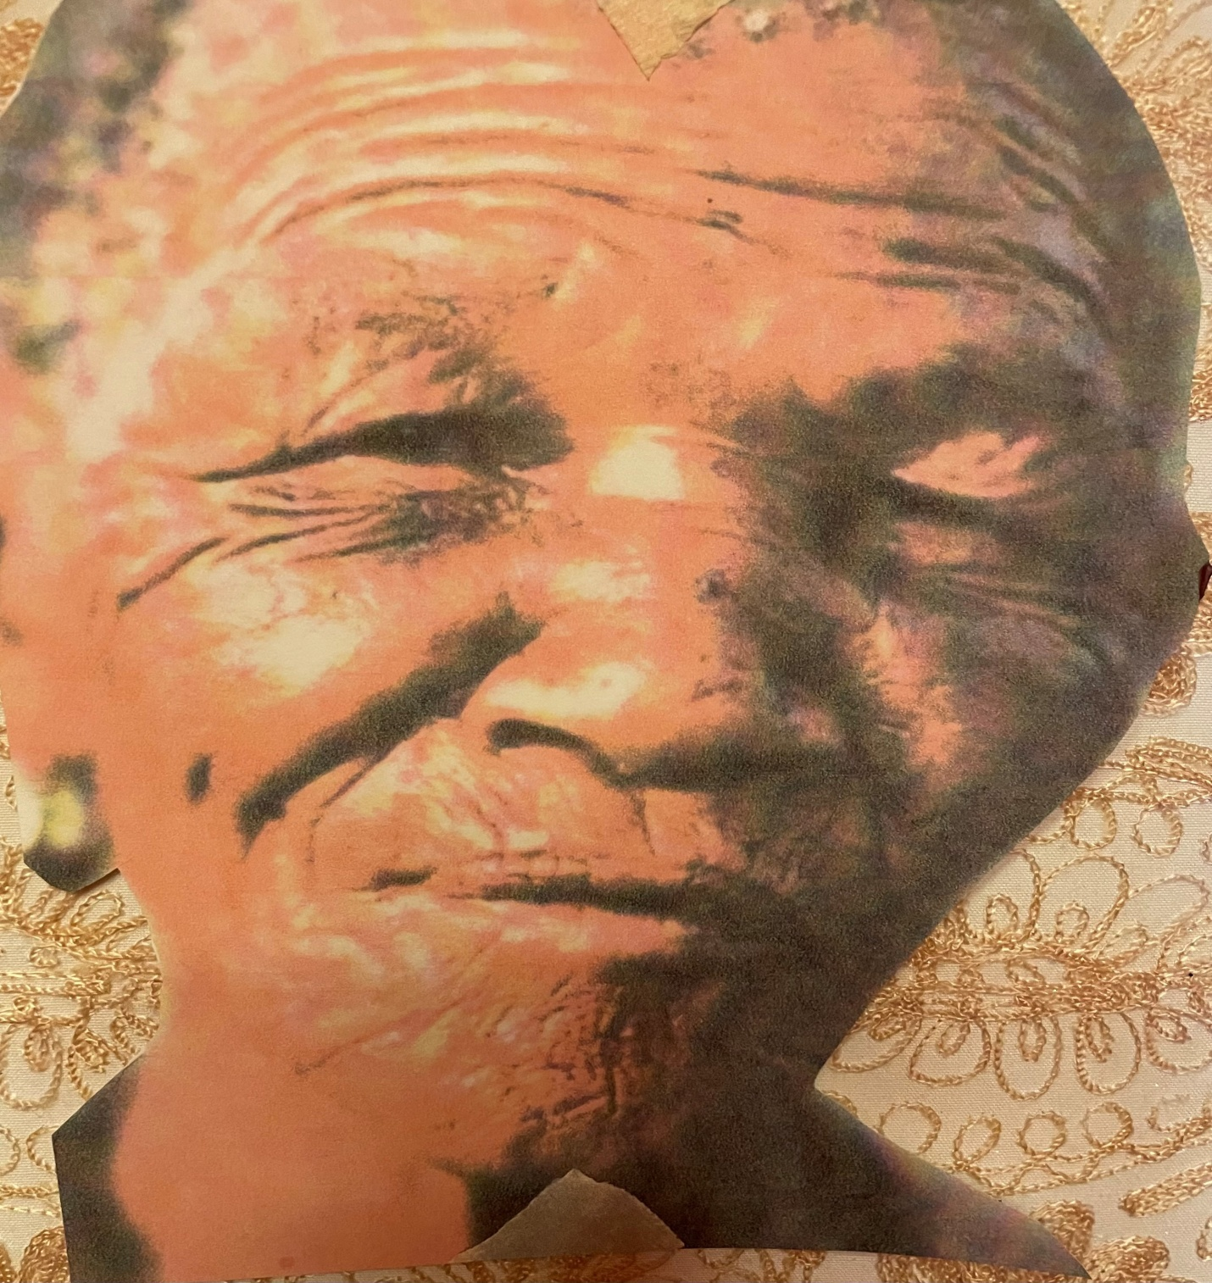
Nana Buruku is the creator of all life in the traditional religious beliefs of the Yoruba people of Benin and Nigeria. She is also venerated as Mami Wata (mother of the waters) in West African Vodun, Haitian Vodou, Folk Catholicism, Odinani and Louisiana voodoo.
She is the grandmother of all Orisha (guiding and protecting spirits). She watches over all women. They come to her for guidance and spiritual healing.
She birthed the sun and the moon. She is the light that shines at night, like the moon, always present but not always seen. She is the mother always looking out for her children. She controls the water and the land that she holds in her hands.
Her colors are pink and purple and are used in altars invoking her powers. Cowrie shells are associated with women's anatomy. They were a form of currency in the past, traded for slaves. The cowrie shell necklace today symbolizes prosperity in Africa, North and South America. In Africa it also symbolizes fertility.

