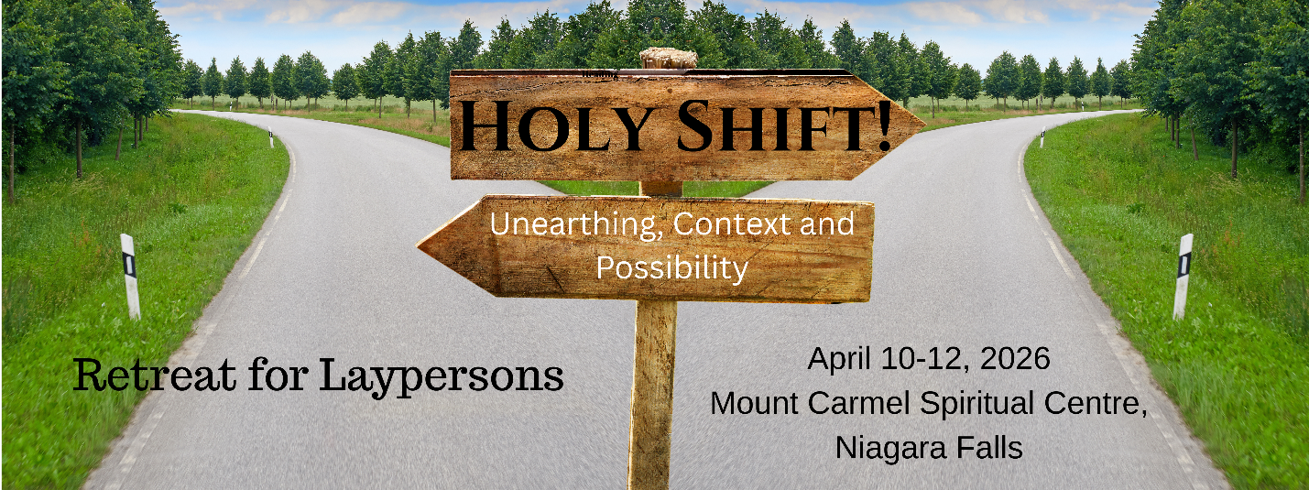
Dear Friends,
This letter is written to invite laypersons of the Eastern Synod, ELCIC, and the Diocese of Niagara, Anglican Church of Canada, to attend a spiritual retreat.

Our theme this time will be: HOLY SHIFT - Unearthing, Context and Possibility!
Our world is experiencing a shift - what was our norm even ten years ago in the community and church certainly is not what is today. And that's ok.
We would like to take some time over our retreat to reflect on who our communities are, what we have in our midst as we examine our individual contexts and look at what is the work we have been called into as Lutherans and Anglicans in our communities. What does it mean to be a leader in our church in 2026? Our time will hold three pieces, who are we - the stories of ministry, where are we - what does it mean to be Lutheran or Anglican in our places and spaces and what exactly is our context, and what is possible- how do we think about ministry in different ways. We will draw from our own experiences, Canadian examples and scholars who have been wrestling with these themes. Come and be a part of this work together as we live out what it means to be God's people in this time and these places. May we be strengthened for service in this world!


Our guest speaker is the Rev. Dr. Anne Anderson, Assistant Professor of Pastoral
Leadership and Contextual Ministry Scholar- In - Residence, in addition to serving as
community pastor, leading the thirdspace alternative worshipping community, Anne
teaches in contextual ministry courses as well as guest lecturing in various courses; she
is also program coordinator for the MDiv and MA in Spiritualities and Community Engagement.
Anne received her BA in International Development Studies from Wilfrid Laurier University in 2001, her MDiv from Waterloo Lutheran Seminary (Martin Luther University College) in 2006, and her PhD in Human Relationships in the field of Pastoral Leadership from Luther in 2024. Before joining Luther, Anne served as co-pastor at Trinity Evangelical Lutheran Church in New Hamburg, ON (2006-2014). Anne is interested in how emerging faith communities in Canada foster leadership and growth of community, social issues facing young adults, such as mental health and food insecurity - and how faith communities are engaging in this work, hospitality, and welcome - as well as interfaith dialogue and alternative forms of worship and preaching.

Accompanying Anne as part of this year’s retreat leadership program will be Dr. Rebekah Ludolph and Rev. Katherine Gohm in their capacities with the By Living Waters Ministry School at Martin Luther University College.

To register, visit: https://form.jotform.com/252224519470252

The registration fee is $325, commuter only rate is $160 – Payment can be made through the on-line registration form or by sending or dropping off a cheque directly to The Eastern Synod 74 Weber St W. Kitchener, ON N2H 3Z3.
Please make the cheque payable to “The Eastern Synod”. Your registration will not be complete until payment has been received.

*note that the registration deadline is Friday March 27th, 2026.*

ACCOMODATIONS:

- We will be housed in the main building.
- There is a total of 45 guestrooms available.
- Retreatants should arrive Friday between 6:00 pm and 7:00 pm. The program begins at 7:00 pm.
- There will be opportunity for social times, so you may wish to bring refreshments to share.
- Albs will not be required this year.
- The retreat will end following lunch on Sunday April 12th..
- Questions? Please Email Cindy (cstubbs@elcic.ca) or Liz (ezehr@elcic.ca) at the synod office.

Looking forward to seeing you there!



Bishop Carla Blakley

