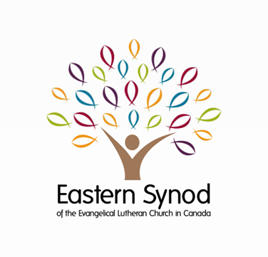
Financial Update
As of May 31, 2024

Offerings Received ($)

 | Regular Benevolence | Canadian Lutheran World Relief
Month of May: 2023 | 91,992 | 16,995
2024 | 97,531 | 13,888
January to May: 2023 | 364,712 | 74,902
2024 | 352,829 | 61,184
Change (2024 vs. 2023) | -3.3% | -18.3%

Your offerings support a variety of vibrant and important ministries of the Eastern Synod and the Evangelical Lutheran Church in Canada, extending the reach of your congregation’s mission across Canada and the world.

For details of these ministries, refer to:
- 2024 – 2027 Eastern Synod Budgets
- CLWR Website

Thank you for your continued partnership,
generosity and support!

Congregational Treasurers:
Please remember to remit your offerings on a regular (monthly) basis.

Keith Myra Mandi Walker
Treasurer Manager of Finance and Administration

