BHM 2024 THEME: Culture/Diversity
May your choices reflect your hopes, not your fears.
-Nelson Mandela
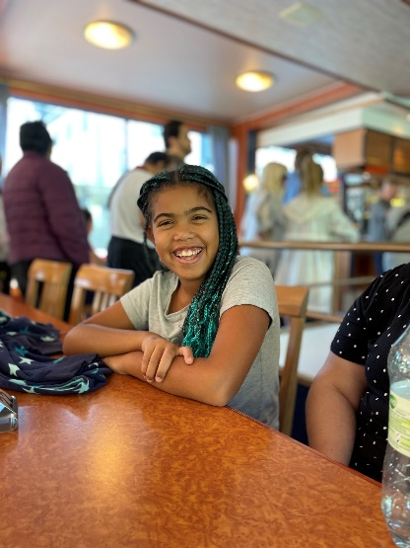
Isla Miller – for Eastern Synod Black History Month 2024
Isla is a member of St. Matthew’s Lutheran Church, Conestogo. She is 11 years old and in grade 6. The following is based on a recent interview with Isla:
1. What did it mean to you to be a part of theBlack Brilliance Club?
Being in the Black Brilliance club, to me meant that I was part of something and not just anything. A club where I can represent my family and culture and I got to be a black role model for the little black girls and boys in my school. In this club, I got to be me.
2. Why do you think it is important to have a club like this?
I think it is important to have a club like this because there are so many black people in the world and my school. When they started Black Brilliance, people like me had a chance to shine and a chance to have a say. It is also a space where we get to be around people who share some similar experiences, culture, food, and beliefs.
3. What would you want to say or share with other kids who look like you?
If I were to offer advice to others, I would say to keep going no matter how difficult it may get or how unfair it may be. You will get through it. And, hey, you may become as great as Viola Desmond, Rosa Parks, Maya Angelou, or Michelle Obama.
4. What is the best part of being you?
I love being me! I love being black and I love being a girl (most times). My favourite colour is pink, but I love that I am a mix of colour. I love my culture and I love my traditional foods, especially curry chicken – I cannot say no to that. Every part of me I love because every part makes up me and I love that I love me.

