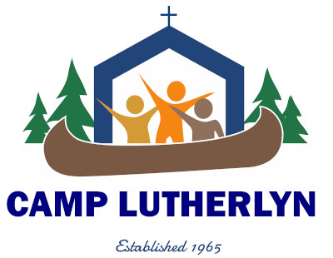
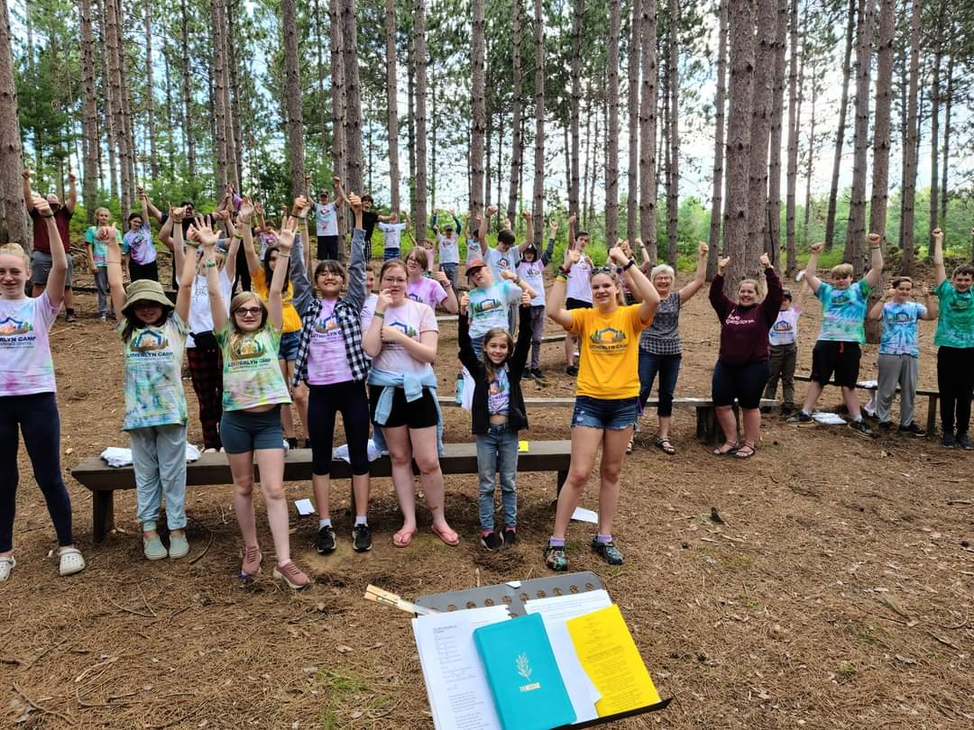
CONFIRMATION CAMP
JULY 5-10 2026
JOIN US ON BEAUTIFUL GOLDEN LAKE FOR A WEEK OF LEARNING, SWIMMING,
FUN AND MORE FUN!

Pastors and Confirmation Teachers Please consider this as a wonderful addition to your program.
The cost for the week is $425/youth. The registration ($525) is reduced by $100 due to a grant from the Eastern Synod missions Committee.

this year to Register go to https://camplutherlyn.campbrainregistration.com/
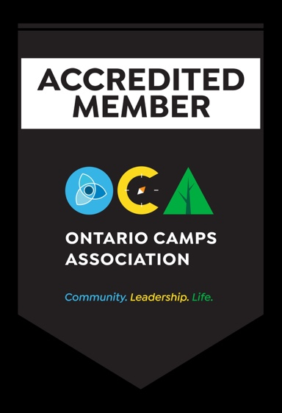
to receive the $100 discount use the
promo code: CC 2026

FOR MORE INFO PLEASE TALK TO YOUR PASTOR or CONTACT REV. SCOTT SCHELLENBERGER AT ZION PEMBROKE 613-732-8792 or sschellenberger@hotmail.com.

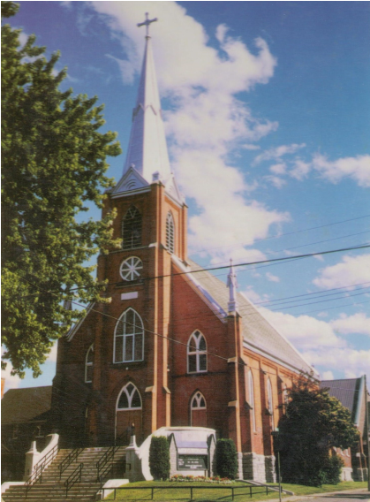
ZION EVANGELICAL LUTHERAN CHURCH

E.L.C.I.C.
454
Miller St., Pembroke, Ontario K8A 5Z4
Telephone: 613-732-8792 Fax: 613-732-1650
e-mail: zionoffice@nrtco.net
www.zionlutheran.ca

“Celebrating God as We Serve Others”

Dear friends in ministry,
I am writing to invite you and your confirmation class to join me next summer from July 5-10 2026 for a week of “Confirmation Camp” at Camp Lutherlyn on Golden Lake - www.lutherlyncamp.ca. Confirmation Camp is a week where 30 young people from several different churches gather for instructions, to meet new friends, and to have fun! This is the first time Camp Lutherlyn is endeavouring to make this happen.

Each day you would gather with the confirmands from your group for an individual lesson (this may
involve only the kids from your congregation or you could work in team with another church). Sizes of classes do not matter. In the beautiful and serene setting of Camp Lutherlyn, daily worship and camp-wide activities would be provided by counsellors and they would also bunk with the confirmands while you get a restful night sleep. The camp will also provide all meals.

The cost for the event for each participant is $425. Again, this covers everything from accommodations to meals. The Missions Committee is giving each camper a $100 grant. Pastors or leaders will pay $525 and stay in Four Seasons Lodge.

We have grants for the first thirty campers. First come first serve. Please share your intended commitment with me as soon as you know so when talking with others I may share our total registration numbers if asked. Registration this year will be through the Camp Lutherlyn website https://camplutherlyn.campbrainregistration.com/ and will be available in the new year.

Please contact me at sschellenberger@hotmail.com or (705)313-0333 to submit your numbers or if
you have any questions.
Sincerely,
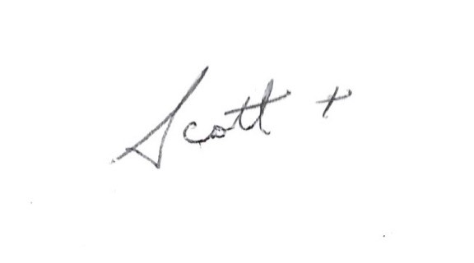

Rev. Scott Schellenberger Zion Lutheran Church, Pembroke

