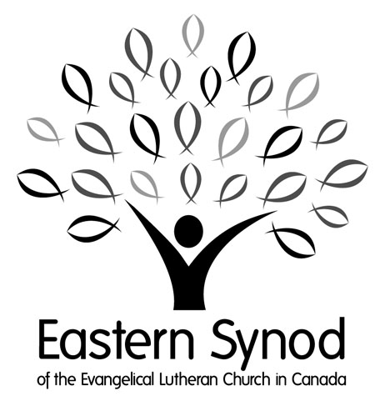
For the school year: 2025/2026

Scholarship Information

History and Purpose
The purpose of these scholarship funds is to provide financial support to those young Christians wishing to or currently pursuing a post-secondary education. All funds are administered by a Scholarship Committee appointed by the Eastern Synod Council. This financial support is available for the 2025-2026 academic year. Below is the scholarship fund that, subject to available funding, is open for qualified candidates to apply.

The Spencer-Barche Educational Trust Fund was established in 1983 and coordinated by the Eastern Synod to encourage young Christian people to pursue a vocation in which they continue to serve their Lord.

All scholarships are administered by the Eastern Synod and applications will be reviewed by a committee appointed by the Eastern Synod Council.

The number of awards will be based upon the number and needs of the applicants. The awards for the Synod Scholarship Fund will be made whenever funds are available.

Eligibility

*Awards will not normally be made to students in educational institutions of theology (i.e Seminaries) leading to a vocation in the ordained ministry.

The following general guidelines apply to awards:
Recipients of awards from the Spencer-Barche Fund must be, and remain during the scholarship period, members of an Eastern Synod Congregation (which can include participation in a campus ministry program), enrolled in or about to enroll in full time post-secondary studies in a college or university, and be an active participant of the Christian Church.

Recipients will be considered, by the selection committee, based on factors such as:
- Christian Character
- Financial need
- Personality
- Vocational promise
- Academic achievement
- Dedicated participation in the church and community.

*Previous recipients are eligible to apply for subsequent scholarships

Filing an Application
Each applicant will be responsible for ensuring that the following are submitted to the Selection Committee by the deadline of Friday May 30th 2025:
- The enclosed application form with Financial Statement.
- Two Letters of Reference. One letter should be from your pastor.
- A photocopy of transcripts from your mid-term marks.

Successful applicants will receive notification of awards in August 2025. Awards will be paid at the beginning of October 2025 subject to verification of full-time enrollment.

Now it is up to you!
If you have any questions, please contact the Eastern Synod Office at (519) 743-1461 or 1-877-373-5242

Note: Late or incomplete applications will not be considered

Send your scanned application by email to Cindy Stubbs @ cstubbs@elcic.ca, OR mail a hardcopy to:
Scholarships
c/o Eastern Synod
74 Weber St W., Kitchener, ON N2H 3Z3

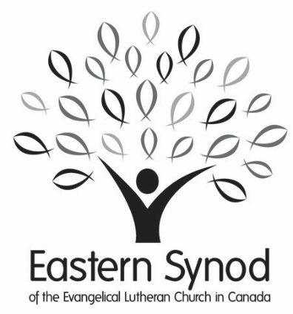

For the school year: 2025/2026

Application Form

Name:
SINGLE |  |  |   MARRIED |  | number of dependents__________
male | FEMALE nonbinary

Home Address:
City: |  |  |  |  |  |  | Province: |  |  |  |  |  |  | Postal Code:
Home Phone: |  |  |  |  |  |  |  |  |  | Cell:

Email:

Date of Birth (Day Month Year):
Educational Institute(s) Applied to: |  |  |  |  |  | __________________________________
Have you previously received a Scholarship through the Eastern Synod? |  |  |  |  |  | Yes |  | No If yes when |  |  |  |  |  |  |  |  |  | _____________________
Signature of applicant: |  |  |  |  |  |  |  |  |  |  |  | Date:

CONFIDENTIAL

Financial Statement

Anticipated Expenses for Year  (September to September) |  |  | Anticipated Income for Year  (September to September)
Accommodation |  |  |  | Savings Accumulated
Board |  |  |  | Gifts from Family
Tuition |  |  |  | Scholarships/Awards
Books & Study Materials |  |  |  | Anticipated from Employment
Incidentals:
Travel (i.e. to school) |  |  |  | Other (i.e. Loans, etc.)  (Please specify)
Personal Items
Other (Please specify)
TOTAL INDEBTEDNESS: |  |  |  | TOTAL ASSETS:

Signature of applicant: |  | Date:

Previous Education

Institution Name:
(High School, etc.)
School Address:
High School Graduation Date:

Church Information

I am a member of:
Church Name:
Address:

Additional Information – Don’t Miss This Section!

On a separate piece of paper, briefly describe your:
- involvement in both church and community activities.
- employment experiences, and
- educational plans.

References
Name:
 |  | Pastor |  | Other
Address:
Email:
Phone #:

