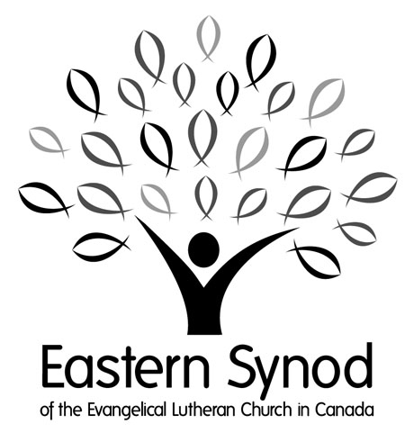
For the school year: 2023/2024

Scholarship Information

History and Purpose
The purpose of these three scholarship funds is to provide financial support to those young Christians wishing to or currently pursuing a post-secondary education. All funds are administered by a Scholarship Committee appointed by the Eastern Synod Council. This financial support is available for the 2023-2024 academic year. Below is a list of scholarship funds that, subject to available funding, are open for qualified candidates to apply.

The Synod Scholarship Fund is a program administered by the Eastern Synod of the Evangelical Lutheran Church in Canada when funds are available. It was established in 1995 to encourage young Christian people to enrol in a post-secondary institution to pursue a vocation in society as Christian men and women. This scholarship is not normally given to those students studying in educational institutions of theology leading to a vocation in the ordained ministry.
This program is not solely based upon academic achievement, rather, it seeks to make awards to those people who have special financial needs and to encourage their pursuit of a post-secondary education.

The Spencer-Barche Educational Trust Fund was established in 1983 and coordinated by the Eastern Synod to encourage young Christian people to pursue a vocation in which they continue to serve their Lord.

The Toolsie Fund was established in 1984 and is a program administered by the Synod Council appointed Scholarship Committee geared specifically to university students.

All three scholarships are administered by the Eastern Synod and applications will be reviewed by a committee appointed by the Eastern Synod Council.

The number of awards will be based upon the number and needs of the applicants. The awards for the Synod Scholarship Fund will be made whenever funds are available, and for the Spencer-Barche fund on an annual basis with recipients eligible to apply in subsequent years.

Eligibility

*Awards will not normally be made to students in educational institutions of theology (i.e Seminaries) leading to a vocation in the ordained ministry.

The following general guidelines will apply to awards:
Recipients of awards from the Synod Scholarship Fund must be, and remain during the scholarship period, members of an Eastern Synod Congregation (which can include participation in a campus ministry program), who are enrolled in or about to enrol in full time post-secondary studies in a college or university.
Preference will be given to first year students. Recipients will be considered, by the selection committee, based on factors such as:
- Christian Character
- Financial need
- Personality
- Vocational promise
- Academic achievement
- Dedicated participation in the church and community.
*Previous award recipients will not be considered for a second award but may qualify for a Spencer-Barche Fund award (below)

Recipients of awards from the Spencer-Barche Fund are not required to be Lutheran, however, the following criteria will be seriously considered:
- An active member of a congregation of the Eastern Synod
- An active member of a Lutheran congregation
- An active participant of the Christian Church
*Previous recipients are eligible to apply for subsequent scholarships.

Recipients of awards from the J.V.Toolsie Fund must be pursuing an education at a University.

Filing an Application
Each applicant will be responsible for ensuring that the following are submitted to the Selection Committee by the deadline of Wednesday May 31st 2023:
- The enclosed application form with Financial Statement.
- Two Letters of Reference. One letter should be from your pastor.
- A photocopy of transcripts from your mid-term marks.

Successful applicants will receive notification of awards in August 2023. Awards will be paid at the beginning of October 2023, subject to verification of full-time enrollment.

Now it is up to you!
If you have any questions, please contact the Eastern Synod Office at (519) 743-1461 or 1-877-373-5242

Note: Late or incomplete applications will not be considered
Send your scanned application by email to Cindy Stubbs @ cstubbs@elcic.ca, OR mail a hardcopy to:
Scholarships
c/o Eastern Synod
74 Weber St W., Kitchener, ON N2H 3Z3
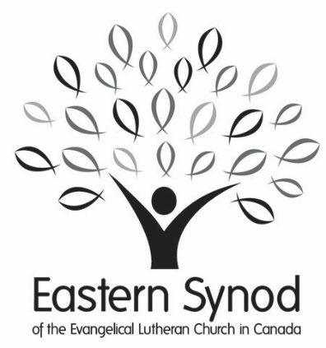

For the school year: 2023/2024

Application Form

Name:
SINGLE |  |  | MARRIED |  | number of dependents__________
male | FEMALE nonbinary

Home Address:
City: |  |  |  |  |  |  | Province: |  |  |  |  |  |  | Postal Code:
Home Phone: |  |  |  |  |  |  |  |  |  | Cell:

Email:

Date of Birth (Day Month Year):
Educational Institute(s) Applied to: |  |  |  |  |  | __________________________________
Have you previously received a Scholarship through the Eastern Synod? |  |  |  |  |  | Yes |  | No If yes when |  |  |  |  |  |  |  |  |  | _____________________
Signature of applicant: |  |  |  |  |  |  |  |  |  |  |  | Date:

CONFIDENTIAL

Financial Statement

Anticipated Expenses for Year  (September to September) |  |  | Anticipated Income for Year  (September to September)
Accommodation |  |  |  | Savings Accumulated
Board |  |  |  | Gifts from Family
Tuition |  |  |  | Scholarships/Awards
Books & Study Materials |  |  |  | Anticipated from Employment
Incidentals:
Travel (i.e. to school) |  |  |  | Other (i.e. Loans, etc.)  (Please specify)
Personal Items
Other (Please specify)
TOTAL INDEBTEDNESS: |  |  |  | TOTAL ASSETS:

Signature of applicant: |  | Date:

Previous Education

Institution Name:
(High School, etc.)
School Address:
High School Graduation Date:

Church Information

I am a member of:
Church Name:
Address:

Additional Information – Don’t Miss This Section!

On a separate piece of paper, briefly describe your:
- involvement in both church and community activities, especially pertaining to music
- employment experiences, and
- educational plans.

References
Name:
 |  | Pastor |  | Other
Address:
Email:
Phone #:

