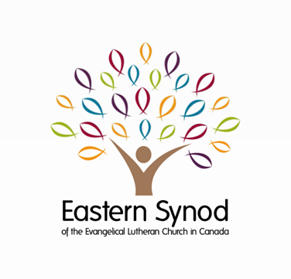
Financial Update
As of November 30, 2023

Offerings Received ($)

 | Regular Benevolence | Canadian Lutheran World Relief
Month of November: 2022 | 104,309 | 18,977
2023 | 99,681 | 15,611
January to November: 2022 | 918,786 | 248,682
2023 | 867,526 | 146,615
Change (2023 vs. 2022) | -5.6% | -39.8%

Your offerings support a variety of vibrant and important ministries of the Eastern Synod and the Evangelical Lutheran Church in Canada, extending the reach of your congregation’s mission across Canada and the world.

For details of these ministries, refer to:
- 2023 Eastern Synod Revised Budget
- CLWR Website

Thank you for your continued partnership,
generosity and support!

Congregational Treasurers:
Please remember to remit your offerings on a regular (monthly) basis.

Keith Myra Mandi Walker
Treasurer Manager of Finance and Administration

